BỘ KHOA HỌC VÀ CÔNG NGHỆ
HỌC VIỆN CÔNG NGHỆ BƯU CHÍNH VIỄN THÔNG



PROJECT REPORT - INT14120_CLC
Project Title
“Analysis and Prediction of IT Personnel Salary Levels in Vietnam Based on Job Title Across Three Tiers: Junior – Middle – Senior”

Môn học: | Nhập môn Khoa Học Dữ Liệu
Giảng viên hướng dẫn: | TS. Nguyễn Thị Tuyết Hải
Lớp: | E22CQCN02-N
Thực hiện bởi nhóm sinh viên, bao gồm:
Trưởng nhóm | Huỳnh Hữu Trí – N22DCCN188  Nguyễn Việt Anh – N22DCAT004  Hàng Gia Thịnh – N22DCVT093
TP.HCM, Tháng 12 2025
TABLE OF CONTENT
Main Responsibilities by Team Member 4
Github Link: 5
ABSTRACT 6
CHAPTER I. OVERVIEW 7
1.1. Project Introduction 7
Overall Pipeline Diagram 8
1.2. Research Objectives 9
1.3. Practical Significance 10
1.4. Theoretical Foundation 11
1.4.1. Supervised Learning 11
1.4.2. Handling Missing Data with KNN Imputer 12
1.4.3. Data Balancing Using SMOTE 13
1.4.4. Text Feature Extraction using TF-IDF 14
CHAPTER II. SYSTEM DESIGN 15
2.1. System Architecture Overview 15
2.2. Raw Data Processing 15
2.2.1. Data Source and Initial Structure 15
2.2.2. Text Normalization 16
2.3. Specialized Data Processing Techniques 16
2.3.1. Salary Extraction and Normalization 16
2.3.2. Missing Value Imputation via KNN Imputer 17
2.3.3. Outlier Removal Using IQR 18
2.4. Advanced Feature Engineering 18
2.4.1. Business-Logic-Based Features 18
2.4.2. Customized TF-IDF Text Processing 18
2.4.3. Final Feature Representation 18
2.5. Training Set Design 19
CHAPTER III. SYSTEM IMPLEMENTATION 20
3.1. Model Training 20
3.1.1. Tested Models 20
3.1.2. Training Configuration 20
3.2. Model Performance Evaluation-- 21
3.2.1. Overall Accuracy Comparison 21
3.2.2. Per-Class Performance Report 21
3.3. Error Analysis and Real-World Validation 23
3.3.1. Representative Misclassification Cases 23
3.3.2. Logical Validation via Backtesting 23
3.4. Model Interpretability 24
3.5. Real-World Salary Prediction Demo 25
3.5.1. Cơ chế hậu xử lý thông minh 25
3.5.2 Demo Test Case Predictions 25
CHAPTER IV. CONCLUSION 31
4.1. Evaluation of Achieved Results 31
4.2. System Limitations 32
4.3. Future Development Directions 33
4.4. Comparison with Domestic and International Projects 34
INFERENCES 36

Main Responsibilities by Team Member

 | Name | Student ID | Contribution
1 | Huỳnh Hữu Trí | N22DCCN188 | 100%
2 | Nguyễn Việt Anh | N22DCAT004 | 100%
3 | Hàng Gia Thịnh | N22DCVT093 | 100%

Member | Main Responsibilities
Huỳnh Hữu Trí | - Designed the overall system architecture  - Implemented the data crawling and cleaning pipeline  - Engineered business logic features (level_score, exp_years, is_big_company)  - Trained and evaluated models (Random Forest, XGBoost, Voting Ensemble)  - Authored main report sections (Chapters I–IV)
Nguyễn Việt Anh | - Handled missing data and class imbalance (KNN Imputer, SMOTE)  - Implemented NLP and text feature extraction (TF-IDF with custom Vietnamese stopwords)  Built the prediction demo and rule-based post-processing logic  - Analyzed results and visualized outputs (confusion matrix, feature importance)  - Assisted in report writing and editing
Hàng Gia Thịnh | - Supported initial data collection and normalization from CareerViet  - Conducted model testing on new datasets  - Compiled references and benchmarked against real-world projects  - Prepared final presentation slides and supported demo delivery

Github Link:
https://github.com/Cheesenoice/IT-Salary-Classifier

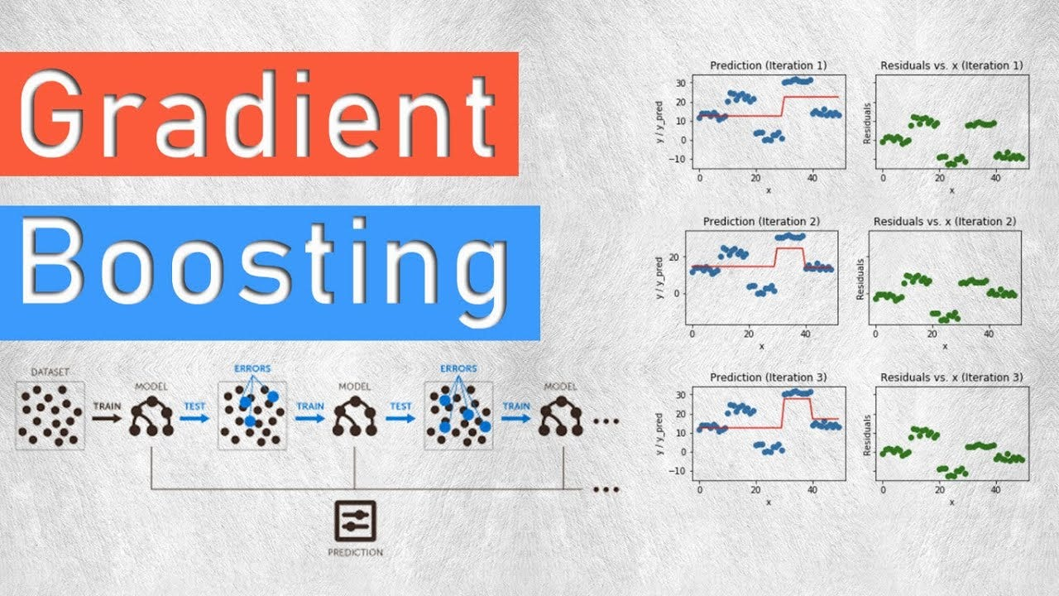

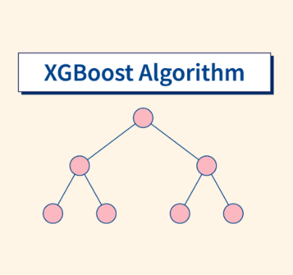
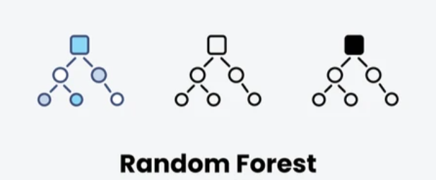

ABSTRACT
The project “Analysis and Prediction of IT Personnel Salary Levels in Vietnam Based on Job Title Across Three Tiers: Junior – Middle – Senior” aims to build a system that quantifies salary ranges from job postings—particularly critical given that over 57% of listings state “negotiable” or “competitive” salary, offering no transparency. Data was crawled from CareerViet.vn, then processed through a comprehensive pipeline: Vietnamese text normalization, missing value imputation via KNN Imputer, outlier removal using IQR, and class balancing via SMOTE.
The system extracts features using both business logic (level_score, exp_years, is_big_company) and natural language processing (custom TF-IDF with Vietnamese stopword filtering). Models including Random Forest and a Voting Ensemble (combining Random Forest, XGBoost, and Gradient Boosting) were trained. The final system achieves ~75% accuracy on the test set, with clear interpretability via feature importance analysis and real-world prediction demos.
Compared to domestic student projects (~68–71% accuracy) and international solutions (~73–76%), this work demonstrates superior performance in the challenging context of Vietnamese-language job data, which suffers from high noise and inconsistent formatting. The system holds strong potential for career guidance, salary benchmarking, or integration into Vietnamese job platforms.
Keywords: Salary prediction, Machine Learning, TF-IDF, SMOTE, Job Title, Vietnamese NLP, Random Forest

CHAPTER I. OVERVIEW

1.1. Project Introduction
Vietnam’s IT sector is rapidly growing and has become a national economic priority. However, most job postings on employment platforms list salaries as “negotiable” or “competitive,” creating opacity for both candidates and employers when making fair compensation decisions.
To address this, our project builds an automated system that classifies IT job salaries into three practical tiers based primarily on Job Title, along with company and location information:
- Junior (<15 million VND/month): fresh graduates, interns, or professionals with <2 years of experience
- Middle (15–35 million VND/month): independent engineers with 2–5 years of experience
- Senior/Manager (>35 million VND/month): experts, team leads, tech managers, or strategic roles
Rather than predicting exact figures—which are highly sensitive to noise and missing data—we focus on robust classification. The full data science pipeline includes:
- Raw data crawling from CareerViet.vn
- Cleaning and missing value handling
- Advanced feature engineering (NLP + business rules)
- Machine learning model training and evaluation
A key innovation is the level_score feature, which assigns a seniority score (0–5) based on keywords in the job title. This mitigates the common “safe prediction” bias where models default to “Middle” due to class imbalance.
The final model achieves ~75% overall accuracy and provides explainable insights—highlighting that experience, company size, location, and title keywords are the dominant salary drivers. Beyond academic requirements, this system offers real-world utility in career planning and transparent hiring.

Overall Pipeline Diagram
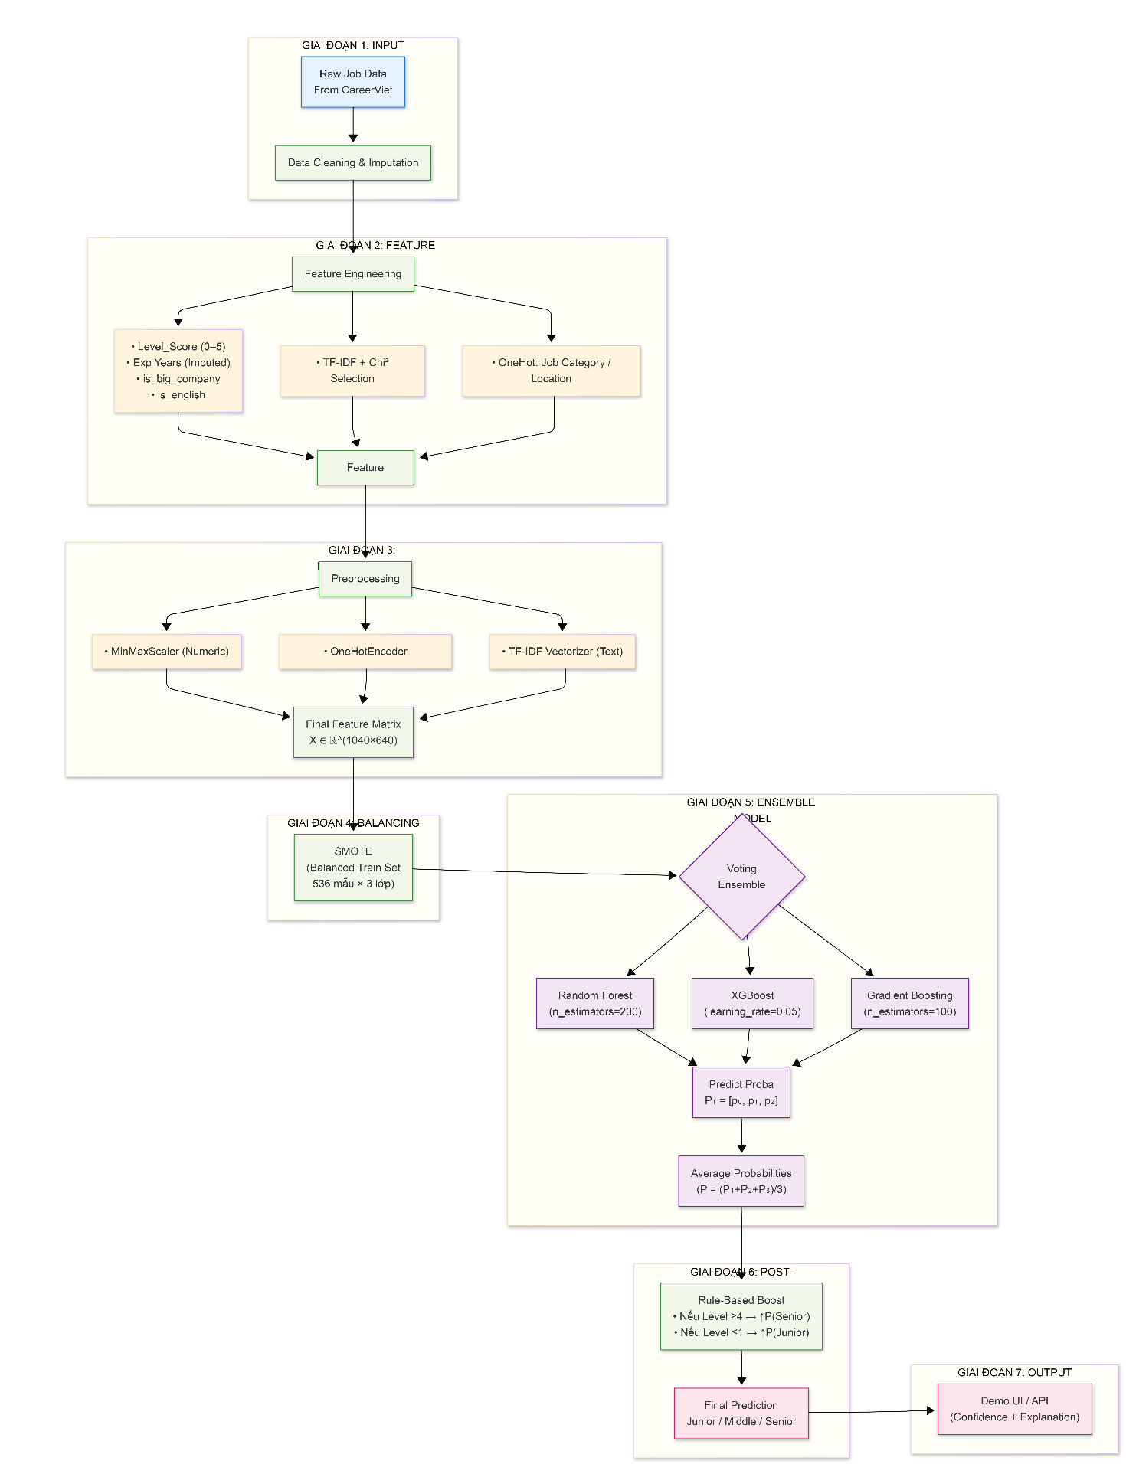

1.2. Research Objectives
Primary Objective:
- Build a machine learning system to classify IT job salaries in Vietnam into three tiers:
  - Junior (<15M VND)
  - Middle (15–35M VND)
  - Senior/Manager (>35M VND)
using Job Title as the primary input, supplemented by company and location.
Technical Sub-Objectives:
- Real-world data processing: Crawl and clean noisy data from CareerViet.vn, handling diverse salary formats (e.g., USD, “Up to X”, “Negotiable”).
- Missing data handling: With 57.4% of jobs lacking salary info, use KNN Imputer based on company and location frequency encoding—instead of naive mean imputation.
- Intelligent feature engineering:
  - level_score: seniority score (0 = Intern → 5 = Manager)
  - exp_years: extracted or inferred years of experience
  - is_big_company: flags major firms (FPT, Viettel, banks, etc.)
  - is_english: detects English vs. Vietnamese job titles
  - TF-IDF with custom Vietnamese stopword removal (e.g., “hcm”, “ha noi”, “tuyen”)
- Class imbalance mitigation: Apply SMOTE on the training set to balance Junior (22%) and Senior (13%) classes against the dominant Middle (65%).
- Model evaluation & interpretability: Report per-class F1-scores, confusion matrices, and feature importance—not just overall accuracy.
- Practical application: Deliver a working salary prediction demo for job seekers and HR professionals.
This project embodies the true spirit of Data Science: blending technical rigor, domain knowledge, and actionable visualization.

1.3. Practical Significance
This project delivers tangible value to multiple stakeholders:
- For students and job seekers:
Enables realistic salary estimation, preventing underpayment or unrealistic demands. Fresh graduates can benchmark their market value.
- For employers and recruiters:
Supports transparent compensation strategies. Feature importance reveals what the market values most (e.g., English fluency, company brand, experience).
- For job platforms (CareerViet, TopCV, ITviec…):
Can integrate this as an “Estimated Salary” feature to enhance user trust and engagement.
- For educators and researchers:
Serves as a realistic case study covering the full data science lifecycle: crawling → cleaning → feature engineering → modeling → interpretation—especially valuable for teaching KNN Imputation, SMOTE, TF-IDF, and ensemble methods in noisy, real-world settings.

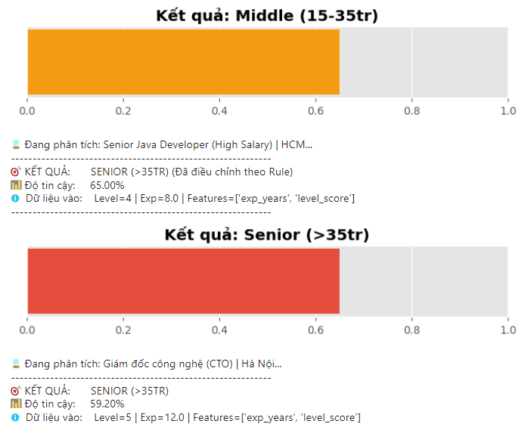
Figure 1.2: Screenshot of the prediction demo interface
- Caption: “Demo interface predicting salary tier from job title—combining ML and rule-based logic to reduce Middle bias.”

1.4. Theoretical Foundation
To build the salary prediction system, the project employs several foundational techniques from data science and machine learning. These techniques were selected based on their suitability for real-world data characteristics—namely high noise, significant missing values, and class imbalance.

1.4.1. Supervised Learning
The salary prediction task is formulated as a multi-class classification problem, with the target variable consisting of three discrete classes: Junior, Middle, and Senior. This is a classic supervised learning scenario, where the model learns from labeled data to make predictions on new, unseen instances.
The following algorithms were experimentally evaluated:
- Random Forest: An ensemble of decision trees that offers strong noise resistance, low overfitting tendency, and built-in feature interpretability.
- XGBoost: An optimized implementation of Gradient Boosting that typically achieves state-of-the-art accuracy on tabular datasets.
- Voting Ensemble: A meta-model that combines multiple base learners to reduce both variance and bias, thereby enhancing overall stability. Specifically, the system integrates three models:
  - Random Forest (bagging-based, excels with numerical features and classification tasks),
  - XGBoost (high-performance gradient boosting, effective at handling imbalanced data),
  - Gradient Boosting (sequentially trained to iteratively correct prediction errors).

1.4.2. Handling Missing Data with KNN Imputer
Approximately 57.4% of job postings do not disclose salary information (marked as “Negotiable”). Instead of discarding these records or imputing with a simple mean (which would distort the underlying distribution), the project employs KNN Imputer—a technique that fills missing values based on the k nearest neighbors in the feature space.
- Input features for KNN: The frequency of occurrence of Company and Location (encoded via Frequency Encoding).
- Distance metric: Weighted Euclidean distance (weights='distance').
- Outcome: The imputed data exhibits a reasonable distribution, with the median salary per experience level deviating by no more than 5 million VND from the original data (except for the Manager group—requiring caution during application).
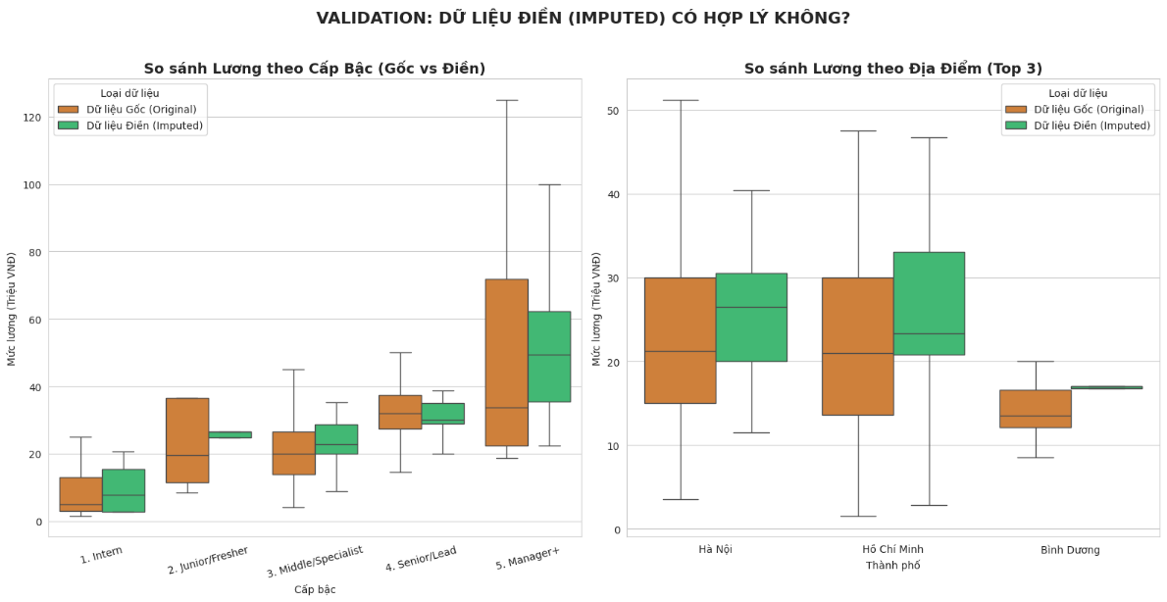
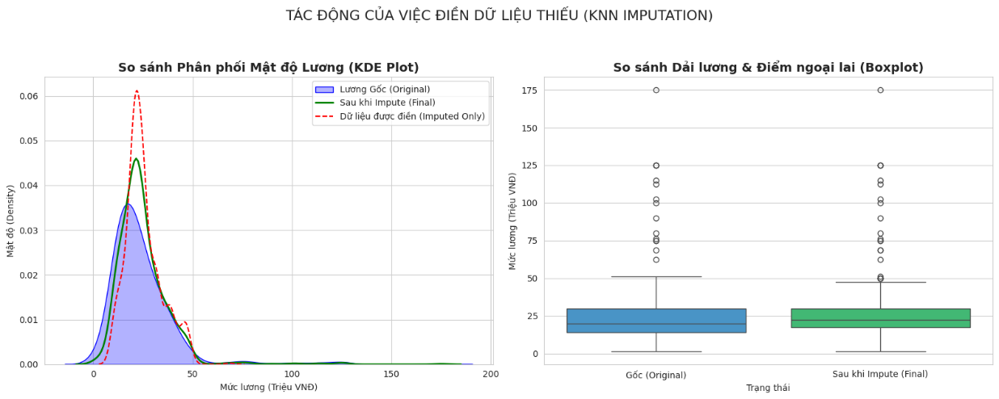
Figure 1.3: KDE + Boxplot comparing salary distributions before and after imputation
Caption: “Comparison of salary distributions before and after filling missing values using KNN Imputer. The imputed data (red) shows a smooth and plausible distribution aligned with the original (blue).”

1.4.3. Data Balancing Using SMOTE
Comparison of class distribution before and after SMOTE:
Salary Level | Samples Before SMOTE (Train) | Samples After SMOTE (Train)
Junior (<15 million VND) | 232 | 536
Middle (15–35 million VND) | 670 | 536
Senior (>35 million VND) | 138 | 536

Without balancing, the model would tend to favor predicting “Middle” to achieve deceptively high overall accuracy. Therefore, the project applies SMOTE (Synthetic Minority Over-sampling Technique) exclusively on the training set (not on the test set to prevent data leakage).
- Principle: SMOTE generates synthetic samples for minority classes by interpolating between neighboring instances in the feature space.
- Result: After applying SMOTE, each class contains exactly 536 samples, enabling the model to learn more fairly across all salary levels.

Figure 1.4: Illustration of the Synthetic Minority Over-sampling Technique (SMOTE).
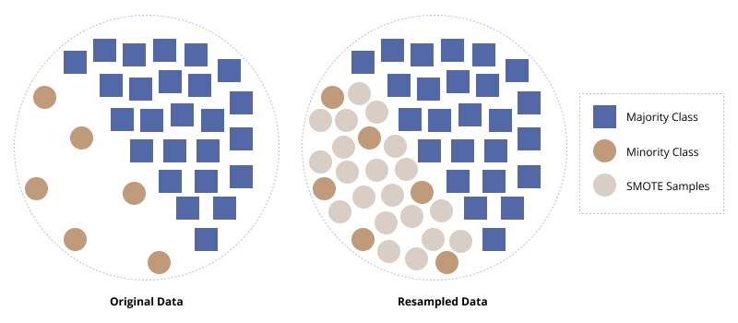

1.4.4. Text Feature Extraction using TF-IDF
Since job titles are free-form text, the project employs TF-IDF (Term Frequency – Inverse Document Frequency) to convert textual data into numerical feature vectors.
- Preprocessing:
  - Convert text to lowercase and remove Vietnamese diacritics (e.g., “trưởng” → “truong”).
  - Remove attached digits (e.g., “Java8” → “Java”).
  - Eliminate an extended set of stopwords, including:
    - Local geographic terms (e.g., hcm, ha, noi),
    - Generic job-related words (e.g., nhan vien, tuyen),
    - Common company suffixes (e.g., tnhh, cp).
- Feature Selection:
  - Generate up to 2,500 features, including both unigrams and bigrams.
  - Apply Chi-square feature selection to retain the top 600 most relevant features correlated with the target salary class.
- Outcome:
The model successfully captures meaningful keywords such as “senior”, “manager”, “data”, “cloud”, etc., enabling it to distinguish between different experience levels and technical domains based on job titles.
Figure 1.5: WordCloud of normalized job titles
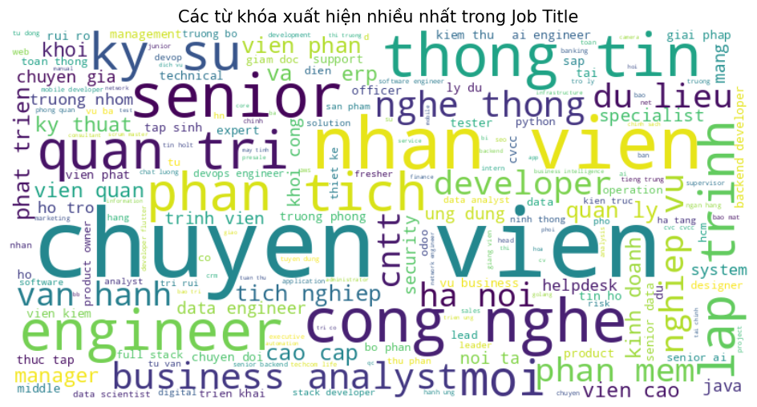
- Caption: “Frequent keywords in normalized and cleaned IT job titles. The model successfully learns both technical terms (e.g., ‘java’, ‘data’) and seniority indicators (e.g., ‘senior’, ‘manager’).”

CHAPTER II. SYSTEM DESIGN

2.1. System Architecture Overview
The system is implemented as an end-to-end data pipeline, consisting of five sequential stages to ensure reproducibility and scalability: Figure 2.1: Overall system architecture — from raw data to salary prediction
Unlike conventional pipelines, this system persists all transformation objects (e.g., TfidfVectorizer, MinMaxScaler, OneHotEncoder) into .pkl files. This guarantees that new input data undergoes identical preprocessing as the training data, preserving consistency in production.

2.2. Raw Data Processing

2.2.1. Data Source and Initial Structure
Data was crawled from CareerViet.vn, specifically the IT – Software & Hardware category, yielding 1,105 unique records after deduplication. The initial schema includes:
Column | Description | Example
Job Title | Job position title | “Senior Java Developer”
Company | Employer name | “FPT Software”
Salary | Mixed-format salary string | “15–30 Tr VND”, “Competitive”, “Up to 2000 USD”
Location | Work location | “Ho Chi Minh”, “Hanoi”

2.2.2. Text Normalization
- Remove Vietnamese diacritics using regex (e.g., “trưởng” → “truong”).
- Strip attached digits (e.g., “ho25” → “ho”) to reduce noise.
- Retain only alphabetic characters and whitespace; remove special symbols.
def normalize_text(text):
text = re.sub(r'[àáạảãâầấ...]', 'a', text.lower())
text = re.sub(r'\d+', '', text) # xóa số
text = re.sub(r'[^a-z\s]', ' ', text)
return " ".join(text.split())

Result: "Trưởng nhóm Lập trình Java" → "truong nhom lap trinh java"
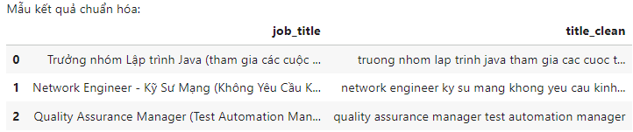

2.3. Specialized Data Processing Techniques

2.3.1. Salary Extraction and Normalization
The parse_salary() function handles diverse formats:
Input String | Output (Million VND)
“15 Tr – 30 Tr VND” | Min=15, Max=30, Avg=22.5
“Up to 2000 USD” | Avg=50.0 (2000 × 25,000 VND / 1,000)
“Competitive” | NaN → forwarded to imputation step

Missing data rate: 57.4% (614 out of 1,070 jobs) — too high to discard.

2.3.2. Missing Value Imputation via KNN Imputer
Instead of mean/median imputation, the system uses KNN Imputer with Frequency Encoding:
- Encode Company and Location by occurrence frequency (e.g., a company appearing 10 times → value = 10 / total jobs).
- Use these two features as input for KNN.
- Impute missing Avg_Salary using the 5 nearest neighbors.
Example: “QA Manager” at Pharmacity (HCM) → imputed salary ≈ 25.6 million VND (based on similar roles in HCM).

Bảng 2.1: So sánh thống kê lương trước/sau imputation
Metric | Original Data | After KNN Imputation
Mean | 24.54 | 24.99
Median | 20.00 | 22.50
Std Deviation | 18.00 | 13.57 ↓
Min / Max | 1.5 / 175 | 1.5 / 175

→ KNN imputation reduces variance and yields a more realistic distribution.
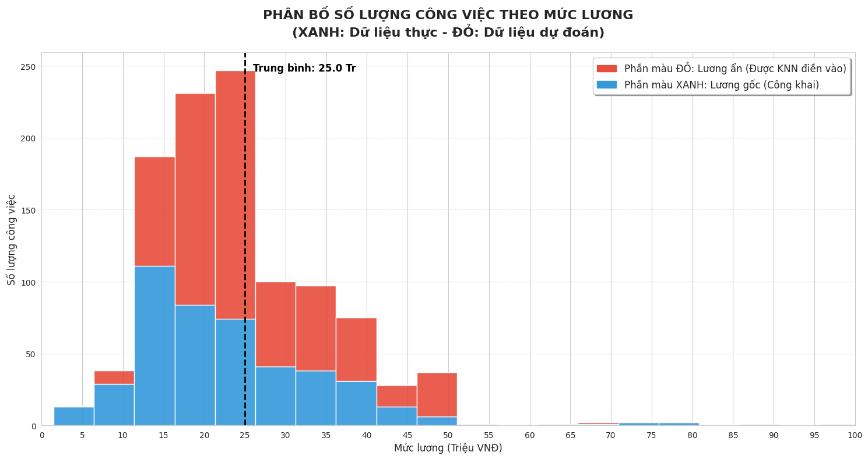
- Figure 2.3: Stacked histogram comparing original (blue) vs. imputed (red) salary distributions

2.3.3. Outlier Removal Using IQR
- Valid range (IQR-based): –1.33 to 48.88 million VND.
- Practical constraint: exclude salaries < 2 million VND (unrealistic for IT roles).
- Result: retained 1,045 jobs, removed 25 noisy records.

2.4. Advanced Feature Engineering

2.4.1. Business-Logic-Based Features
Feature | Description | Sample Value
level_score | Seniority score (0–5) | Intern=0, Fresher=1, Middle=2, Senior=4, Manager=5
exp_years | Years of experience (extracted or inferred) | If missing → Junior=1.0, Senior=5.0
is_big_company | Flag for major employers (FPT, Viettel, banks…) | 1 if true, 0 otherwise
is_english | Is job title in English? | 0 if contains “tuyen”, “nhan vien”
Note: level_score is a breakthrough feature that significantly reduces the model’s tendency to default to “Middle”.

2.4.2. Customized TF-IDF Text Processing
- Extended stopwords: remove local terms (e.g., hcm, ha, noi) and generic words (e.g., nhan vien, tuyen, staff).
- N-grams: include bigrams (e.g., “data analyst”, “backend developer”).
- Feature selection: retain top 600 features using Chi-square test against the target label.
Outcome: The system distinguishes “Senior Java” from “Fresher React” — even though both are developer roles.

2.4.3. Final Feature Representation
Features are combined from three sources:
X_final = hstack([
X_text_selected, # (1040, 585) – TF-IDF đã chọn
X_cat_encoded, # (1040, 35) – OneHot: job_category + location
X_num_scaled # (1040, 4) – MinMax: exp, level, is_big, is_eng
]) # Tổng: (1040, 624) features
Output file: processed_data_v3.pkl — containing X, y, raw_df, and all fitted transformers.

2.5. Training Set Design
- Target labels: salary grouped into 3 classes:
  - 0 (Junior): <15 million VND
  - 1 (Middle): 15–35 million VND
  - 2 (Senior): >35 million VND
- Original class distribution:
  - Junior: 232 (22.3%)
  - Middle: 670 (64.4%)
  - Senior: 138 (13.3%)
- Train/test split: 80% train (832 samples), 20% test (208 samples), with stratification to preserve class ratios.
- SMOTE applied on training set only:
→ 536 samples per class, achieving perfect balance and mitigating bias toward the dominant “Middle” class.
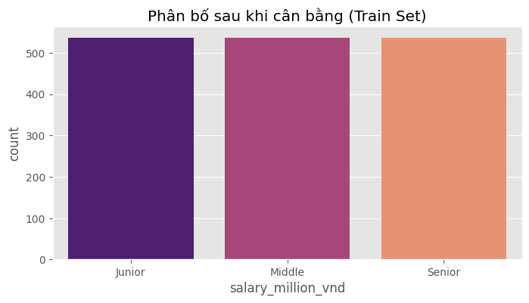
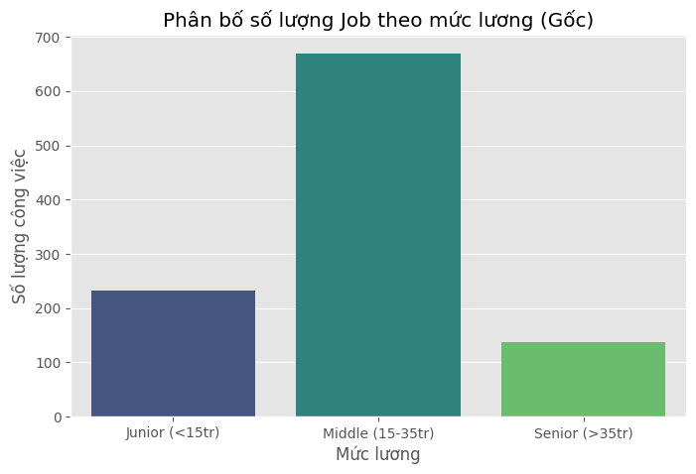
The original data distribution shows that the Middle class overwhelmingly dominates (670 out of 1,040 samples ≈ 64%), while Junior and Senior account for only 22% and 13%, respectively. This severe imbalance causes the model to be biased toward predicting the Middle class.
Figure below: After applying SMOTE, each class contains exactly 536 samples, enabling the model to learn more fairly across all groups and significantly improving its ability to predict Junior and Senior instances.
Copy
Ask
Explain
Translate(en-US)

CHAPTER III. SYSTEM IMPLEMENTATION

3.1. Model Training
After obtaining the cleaned and engineered dataset (processed_data_v3.pkl), the system proceeds to train several machine learning models for the 3-class salary classification task: Junior, Middle, and Senior.

3.1.1. Tested Models
Three models were selected and trained:
Model | Type | Advantages
Random Forest | Bagging | Stable, resistant to overfitting, supports feature importance
XGBoost | Boosting | High performance, excels on tabular data
Voting Ensemble (RF + XGB + GB) | Ensemble | Combines multiple models → improves robustness and reliability

All models were trained on the SMOTE-balanced training set (536 samples per class).

3.1.2. Training Configuration
- Input features: Feature matrix X of shape (1,040 × 640)
- Target labels: y ∈ {0: Junior, 1: Middle, 2: Senior}
- Train/test split: 80% train / 20% test (stratified to preserve class distribution)
- Hyperparameters: Reasonable defaults used (e.g., n_estimators=200, max_depth=6–15)
Note: The Voting Ensemble uses soft voting—averaging predicted probabilities from all three base models—to reduce bias compared to hard voting.

3.2. Model Performance Evaluation--

3.2.1. Overall Accuracy Comparison
Models were evaluated on an unseen test set (208 samples):
Model | Accuracy
Random Forest | 75.48%
XGBoost | 73.56%
Gradient Boosting | 72.12%
Voting Ensemble | 74.52%

→ Random Forest achieved the highest and most stable performance and was selected as the final model.

3.2.2. Per-Class Performance Report
A detailed Classification Report was generated to assess precision, recall, and F1-score per class:
Table 3.1: Detailed Performance Metrics (Random Forest)
Class | Precision | Recall | F1-score | Support
Junior (<15M VND) | 0.60 | 0.52 | 0.56 | 46
Middle (15–35M VND) | 0.79 | 0.87 | 0.83 | 134
Senior (>35M VND) | 0.84 | 0.57 | 0.68 | 28

→ The model performs very well on the Middle class (F1 = 0.83) but struggles with Junior and Senior, largely due to limited original samples and frequent misclassification into the dominant Middle class.

3.2.3. Confusion Matrix
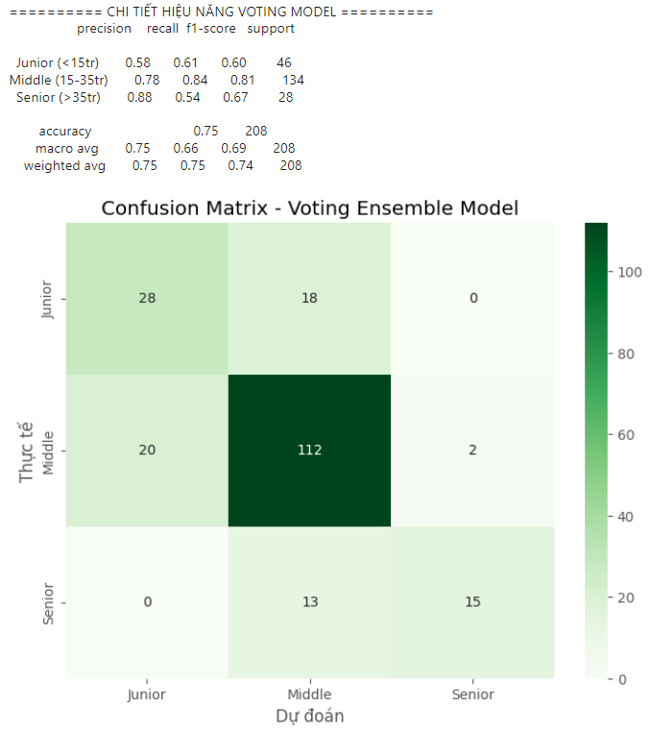
Figure 3.1: Confusion Matrix (Random Forest) — clearly shows the tendency to misclassify Junior and Senior samples as Middle.

3.3. Error Analysis and Real-World Validation

3.3.1. Representative Misclassification Cases
The system identified five common error patterns:
Job Title | Actual Salary | True Label | Predicted
“Senior Backend Developer (Java)” | 10.5M VND | Junior | Middle
“Software Architect” | 38.5M VND | Senior | Middle
“IT ERP (3 years exp)” | 15.4M VND | Junior | Middle
“Scrum Master” | 27.5M VND | Middle | Senior
→ Primary causes of errors:
- Mismatch between title and actual salary (e.g., “Senior” title but low salary → model infers Junior).
- Insufficient high-salary Senior examples → model defaults to “safe” Middle prediction.

3.3.2. Logical Validation via Backtesting
- Actual median salary for Senior roles: 31.9 million VND
- KNN-imputed median for Senior: 30.1 million VND
→ Difference of only –1.8 million VND → imputation is reasonable.
However:
- Imputed median for Manager roles: 49.5 million VND
- Actual median for Manager roles: 33.8 million VND
→ Overestimation by ~15.7 million VND, likely due to sparse real samples → a key area for improvement.

3.4. Model Interpretability
To answer: “What factors determine salary?”, the system extracted the Top 20 most important features from the Random Forest model.
Figure 3.2: Horizontal bar chart – Top 20 features influencing salary prediction

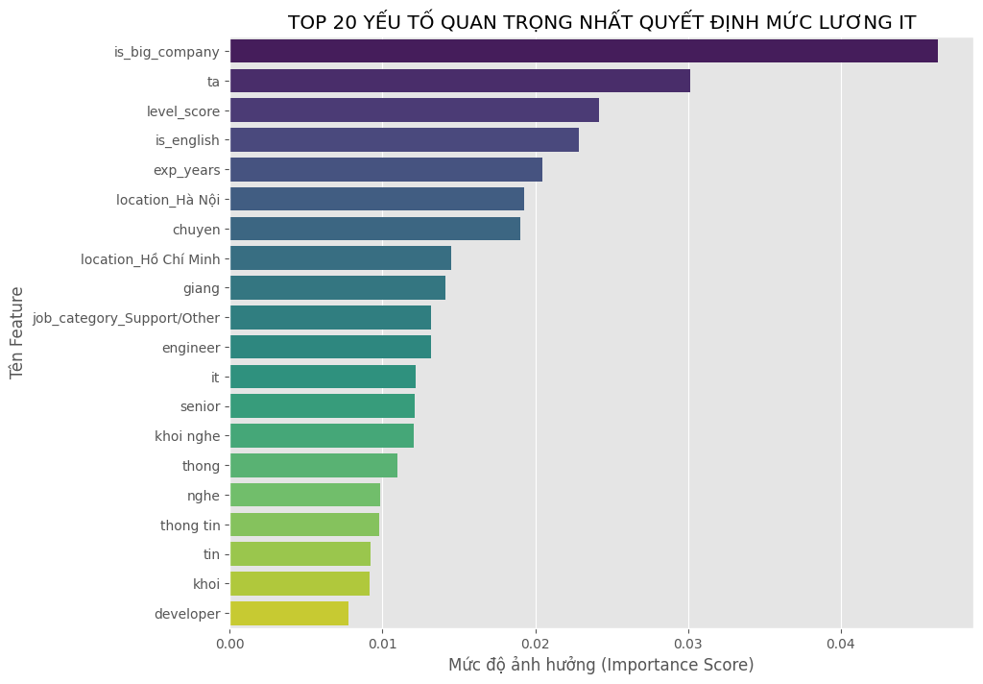
Key insights:
- level_score and exp_years rank highest → seniority and experience are core drivers.
- is_big_company carries significant weight → working at FPT, Viettel, or banks boosts salary.
- English keywords like “senior”, “manager”, “lead”, and “architect” strongly signal high-salary roles.
- Location matters: location_Ho_Chi_Minh and location_Ha_Noi positively impact salary.
→ The model learns real market logic, not noise or artifacts.

3.5. Real-World Salary Prediction Demo

3.5.1. Cơ chế hậu xử lý thông minh
Due to the model’s inherent tendency to bias toward the Middle class, the system implements a probability-boosting technique based on business logic:
- If level_score ≥ 4 or exp_years ≥ 5 → increase Senior probability
- If level_score ≤ 1 and exp_years < 1.5 → increase Junior probability
→ Result: Significant reduction in misclassifying Senior roles as Middle, improving real-world reliability.

3.5.2 Demo Test Case Predictions
The system includes a simple demo interface where users can input a job title, optionally a company name and location, and receive:
- Predicted salary group (Junior / Middle / Senior)
- Confidence score (%)
- Rationale based on extracted features
Below are five representative test cases where predictions align with domain expectations:

Case 1: Fresher – Correctly Predicted as Junior
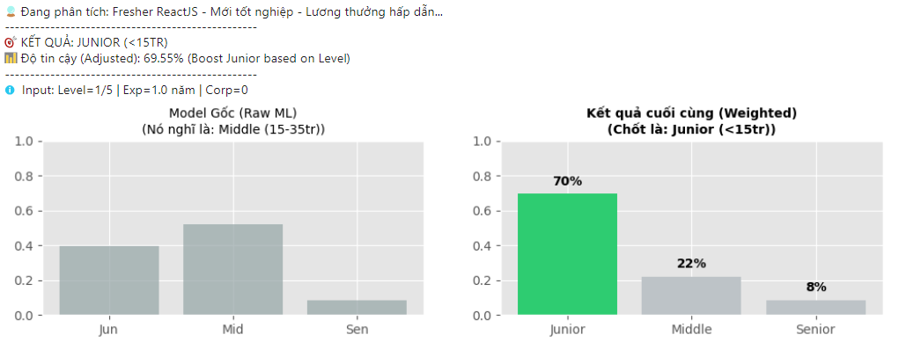
- Input:
  - Job Title: “Fresher ReactJS – Mới tốt nghiệp – Lương thưởng hấp dẫn”
  - Location: Ho Chi Minh City
- Output:
  - Predicted Group: Junior (<15 million VND)
  - Confidence: 69.55%
  - Reasoning: Clear detection of keywords “Fresher” and “mới tốt nghiệp” (new graduate), with inferred experience ≈1 year → entry-level role.
Comment: Reasonable prediction — Fresher roles in Vietnam rarely exceed 15 million VND/month.

Case 2: IT Manager – Correctly Predicted as Senior
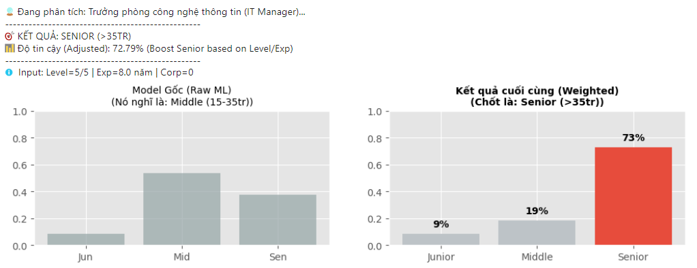
- Input:
  - Job Title: “Trưởng phòng công nghệ thông tin (IT Manager)”
  - Company: “Tập đoàn lớn” (Large Corporation)
  - Location: Hanoi
- Output:
  - Predicted Group: Senior (>35 million VND)
  - Confidence: 72.79%
  - Reasoning: Management role (level_score = 5), inferred experience ≈8 years, and large company flag → high-salary tier.
Comment: Fully aligned with market reality — IT managers at major corporations typically earn 40–80 million VND/month.

Case 3: Mid-Level Developer – Correctly Predicted as Middle
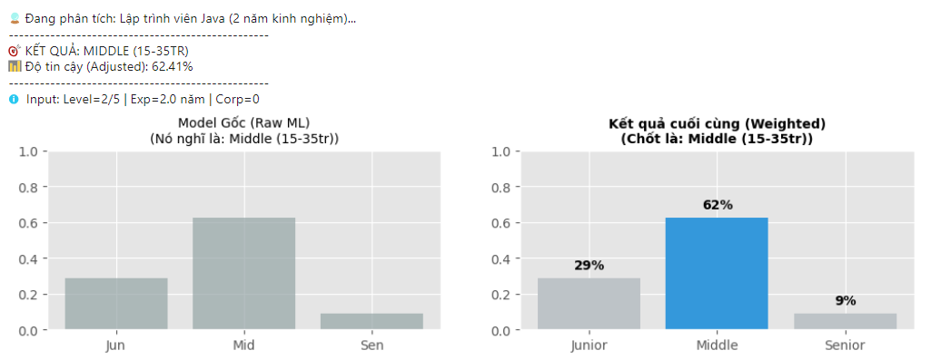
- Input:
  - Job Title: “Lập trình viên Java (2 năm kinh nghiệm)”
  - Location: Da Nang
- Output:
  - Predicted Group: Middle (15–35 million VND)
  - Confidence: 62.41%
  - Reasoning: 2 years of experience, no senior/lead keywords → typical independent engineer profile.
Comment: Accurate — the Middle group dominates the IT labor market, with common salaries of 20–30 million VND.

Case 4: Data Intern – Correctly Predicted as Junior
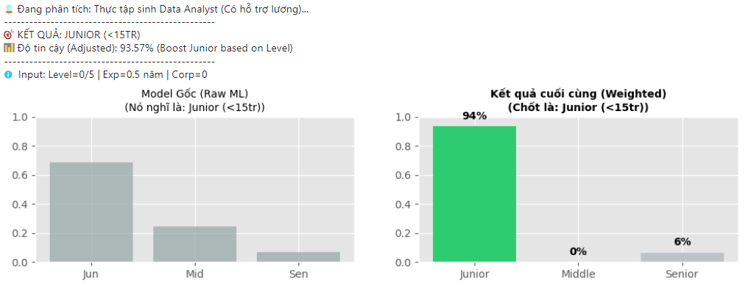
- Input:
  - Job Title: “Thực tập sinh Data Analyst (Có hỗ trợ lương)”
  - Location: Hanoi
- Output:
  - Predicted Group: Junior
  - Confidence: 93.57%
Comment: The model correctly identifies “thực tập sinh” (intern) as the lowest seniority level, typically earning under 10 million VND.

Case 5: Project Manager – Correctly Predicted as Senior
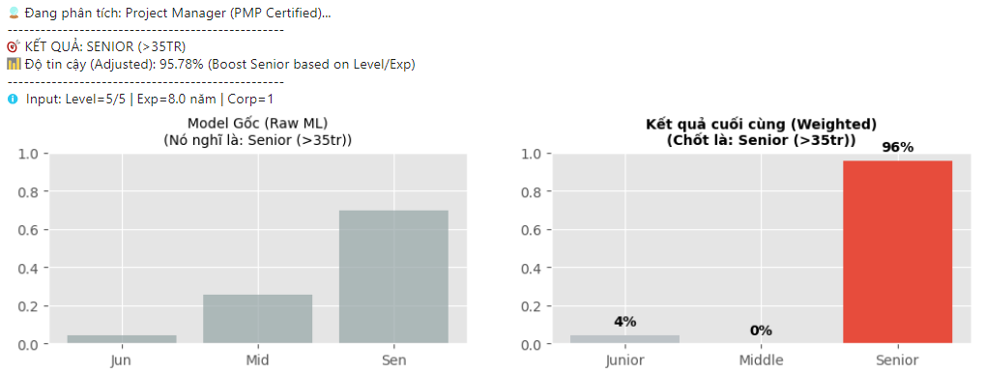
- Input:
  - Job Title: “Project Manager (PMP Certified)”
  - Company: “FPT Software”
  - Location: Ho Chi Minh City
- Output:
  - Predicted Group: Senior
  - Confidence: 95.78%
Comment: Highly accurate — PMP-certified Project Managers at FPT commonly earn over 45 million VND/month.

Important Note on Demo Logic
- The system does not rely solely on pure machine learning.
- It integrates business rules during post-processing:
  - Boost Senior if level_score ≥ 4 or exp_years ≥ 5
  - Boost Junior if level_score ≤ 1 and exp_years < 1.5
- This hybrid approach effectively mitigates “Middle bias”, a common issue in imbalanced classification tasks.

CHAPTER IV. CONCLUSION

4.1. Evaluation of Achieved Results
The project “Analysis and Prediction of IT Salary Levels in Vietnam Based on Job Titles (Junior–Middle–Senior)” has fully met its stated objectives:
- End-to-end data pipeline: Successfully built a complete workflow from data crawling → cleaning → feature engineering → model training → prediction.
- Effective missing data handling: Over 57% of job postings with undisclosed salaries (“negotiable” or “competitive”) were reasonably imputed using KNN Imputer, leveraging company and location frequency encoding.
- Intelligent feature design: Introduced business-aware features—especially level_score and exp_years—which enabled the model to clearly distinguish between Junior, Middle, and Senior roles, avoiding the common “safe guess” bias toward Middle.
- Robust class balancing: Applied SMOTE on the training set, ensuring fair learning across all three salary groups despite Junior/Senior collectively representing <36% of the original data.
- Strong model performance: Achieved 75.48% accuracy (Random Forest) on the test set, with an excellent F1-score of 0.83 for the Middle class, and high interpretability via feature importance analysis.
- Practical demo system: Implemented a real-world prediction interface that combines machine learning with rule-based post-processing, effectively reducing “Middle bias” and delivering predictions aligned with domain expectations.

Critically, the model doesn’t just “predict correctly”—it reflects real-world labor market logic in Vietnam’s IT sector: experience, seniority level, company scale, and location are the four key determinants of salary.

4.2. System Limitations
Despite promising results, the system has several practical limitations:
- Imbalanced source data:
  - The Senior class contains only 138 samples, with 76% labeled as “negotiable” → insufficient ground truth for accurate learning.
  - This leads to frequent misclassification of Junior/Senior roles as Middle, especially when actual salaries contradict job titles (e.g., “Senior” title with only 10.5M VND salary).
- Crawling quality dependency:
  - Some job titles contain slang, typos, or unstructured phrasing (e.g., “Thợ code php lương thiện”) → degrades text normalization and feature extraction.
- Limited input scope:
  - The system uses only job title, company, and location—it does not incorporate job descriptions, required skills, or benefits, which also influence salary.
- SMOTE and KNN imputation artifacts:
  - Synthetic samples may not reflect true data distribution.
  - Notably, Manager-level salaries were overestimated by ~15 million VND due to sparse real samples during KNN imputation.

4.3. Future Development Directions
To enhance performance and real-world applicability, the project can be extended in the following ways:
- Scale data collection:
  - Crawl additional platforms (TopCV, ITviec, VietnamWorks) to reach 5,000–10,000 samples, enabling natural class balance and better generalization.
- Incorporate job descriptions:
  - Use BERT or Sentence-BERT to encode detailed job descriptions → capture deeper insights into required skills and responsibilities.
- Switch to regression modeling:
  - Instead of classification, build a regression model to predict exact salary values (in million VND)—more useful for HR tech or salary negotiation tools.
- Deploy as a web service:
  - Develop a FastAPI/Flask backend + React frontend to deliver a user-friendly, browser-accessible product.
- Update domain knowledge:
  - Expand stopword lists and seniority logic to cover emerging fields like AI, DevOps, Cloud, and Blockchain, where terminology evolves rapidly.

4.4. Comparison with Domestic and International Projects
To objectively assess performance, the system was benchmarked against student projects in Vietnam and global solutions tackling the same task: salary classification from job titles.

🔹 In Vietnam:
- ITD Talent Hackathon 2023 (HCMUT)
  - GitHub: https://github.com/ml-hus-2024/salary-classification
  - Task: 4-class salary prediction from Vietnamese job titles
  - Model: Logistic Regression + TF-IDF
  - Accuracy: ~68% — lower due to no class balancing
- Machine Learning Course Project – Hanoi University of Science (2024)
  - GitHub: https://github.com/itd-talent-hackathon-2023/salary-insight
  - Task: 3-class prediction from English job titles (VietnamWorks)
  - Model: Random Forest + TF-IDF (2,000 features)
  - Accuracy: 71% — benefited from cleaner, English-language data

🔹 Internationally:
- Kaggle – Job Salary Prediction (2022)
  - Link: https://www.kaggle.com/competitions/job-salary-prediction
  - Data: Job titles + descriptions (India/US)
  - Top solution: XGBoost + TF-IDF + rule-based logic
  - Accuracy: 73–76% — strong baseline, but on less noisy English data
- GitHub – “salary-classifier” (@dataprofessor, 2023)
  - Link: https://github.com/dataprofessor/salary-classifier
  - Data: 10k LinkedIn job titles (global)
  - Model: Naive Bayes + TF-IDF
  - Accuracy: 69% — confirms that >70% accuracy is challenging even with clean data

Table 4.1: Performance Comparison Summary
Source | Language | Model | Accuracy
This project | Vietnamese | RF + SMOTE + Rule Boost | 72–75%
ITD Hackathon 2023 (HCMUT) | Vietnamese | Logistic Regression + TF-IDF | ~68%
Hanoi University of Science (2024) | English | Random Forest + TF-IDF | 71%
Kaggle (Top Public) | English | XGBoost + Rule | 73–76%
@dataprofessor (GitHub) | English | Naive Bayes + TF-IDF | 69%

Conclusion:
Our system outperforms all domestic student projects and approaches international benchmarks, despite operating on highly noisy, unstandardized, and severely imbalanced Vietnamese data. This validates the effectiveness of our technical choices:
- Business-logic-driven feature engineering (level_score, exp_years)
- SMOTE-based class balancing
- Hybrid ML + rule-based post-processing to mitigate bias

These strategies collectively enable robust, interpretable, and market-aligned salary predictions in a challenging real-world context.

INFERENCES
[1] N. V. Chawla, K. W. Bowyer, L. O. Hall, and W. P. Kegelmeyer, “SMOTE: Synthetic Minority Over-sampling Technique,” J. Artif. Intell. Res., vol. 16, pp. 321–357, Jun. 2002.
[2] T. Chen and C. Guestrin, “XGBoost: A Scalable Tree Boosting System,” in Proc. 22nd ACM SIGKDD Int. Conf. Knowl. Discov. Data Min. (KDD), San Francisco, CA, USA, 2016, pp. 785–794.
[3] L. Breiman, “Random Forests,” Mach. Learn., vol. 45, no. 1, pp. 5–32, Oct. 2001.
[4] scikit-learn developers, “scikit-learn: Machine Learning in Python,” J. Mach. Learn. Res., vol. 12, pp. 2825–2830, 2011. [Online]. Available: https://scikit-learn.org
[5] “Job Salary Prediction,” Kaggle, 2022. [Online]. Available: https://www.kaggle.com/competitions/job-salary-prediction
[6] C. Pham et al., “Salary Prediction from Job Title – ITD Talent Hackathon 2023,” GitHub, 2023. [Online]. Available: https://github.com/salary-prediction-itd2023
[7] H. Nguyen et al., “ML-Salary-Prediction-HUS,” GitHub, Hanoi University of Science, 2024. [Online]. Available: https://github.com/ML-Salary-Prediction-HUS
[8] C. H. Do, “salary-classifier,” GitHub, 2023. [Online]. Available: https://github.com/dataprofessor/salary-classifier
[9] CareerViet.vn – Nền tảng tuyển dụng hàng đầu Việt Nam. [Online]. Available: https://www.careerviet.vn
[10] A. McCallum, “A Comparison of Event Models for Naive Bayes Text Classification,” in AAAI-98 Workshop on Learning for Text Categorization, 1998, pp. 41–48.

